Name : S.Logeshwari Reg No:731621205029

Dept : Information Technology Tittle : SQL Lab Practice2

College : KSR Institute for Engineering and Technology

Creating the Sales table :

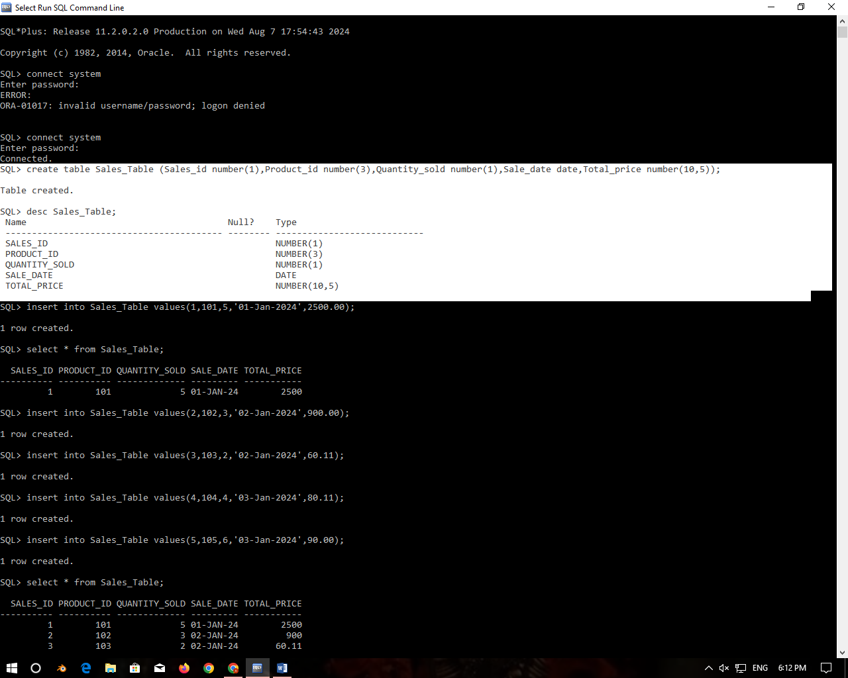

TASK :

**1.Retrieve all columns from the Sales table.**

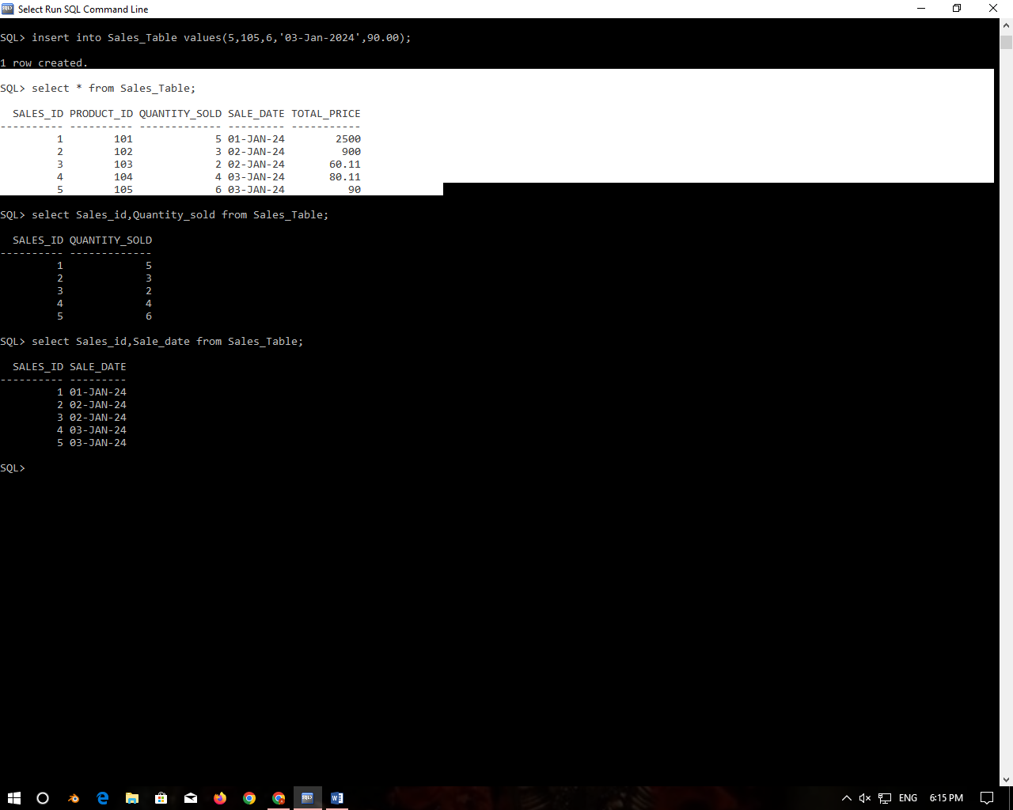

**2.Retrieve sale_id and quantity_sold from sales table.**

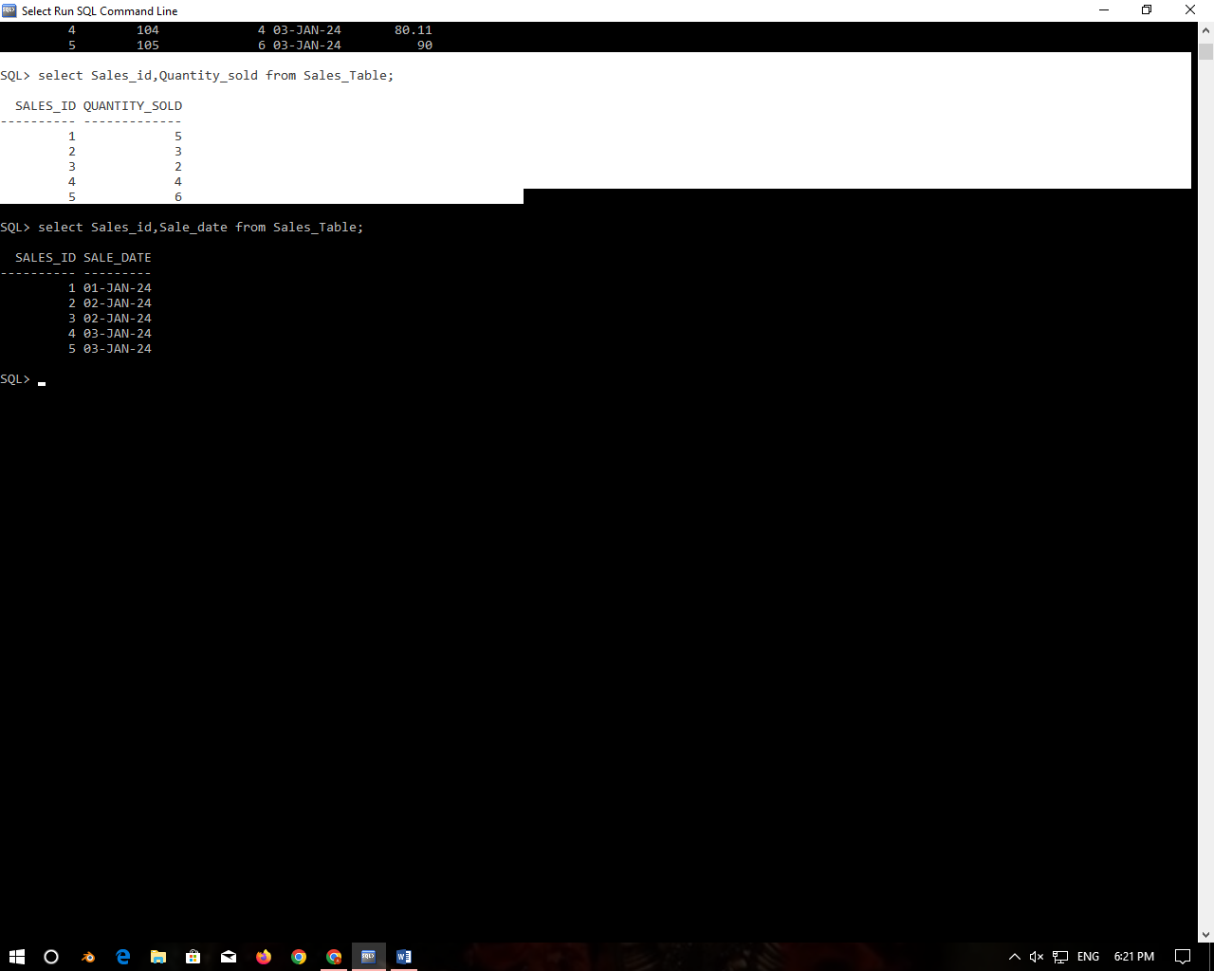

### 3.Retrieve the sale_id and sale_date from the Sales table.

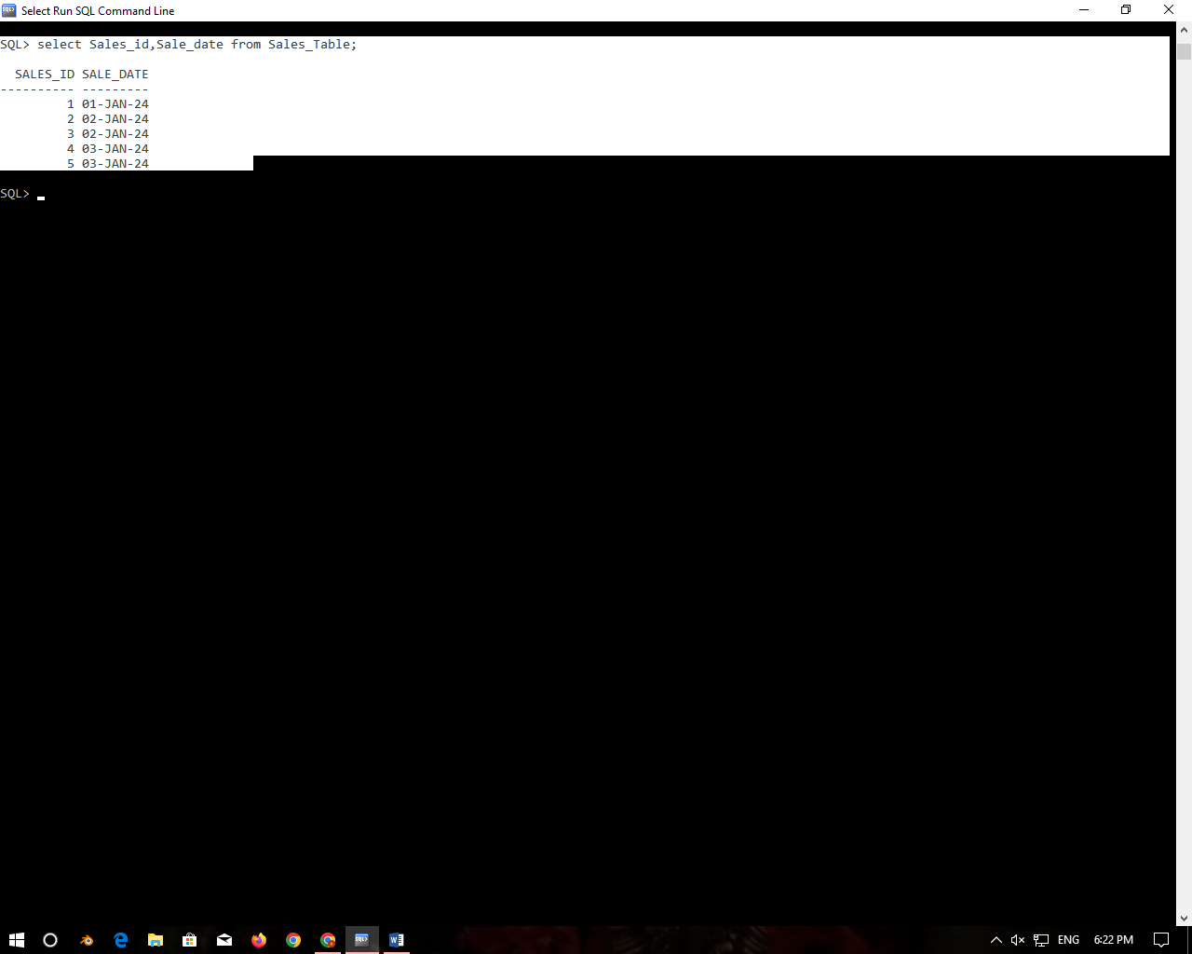

### 

### 4. Filter the Sales table to show only sales with a total_price greater than $100.

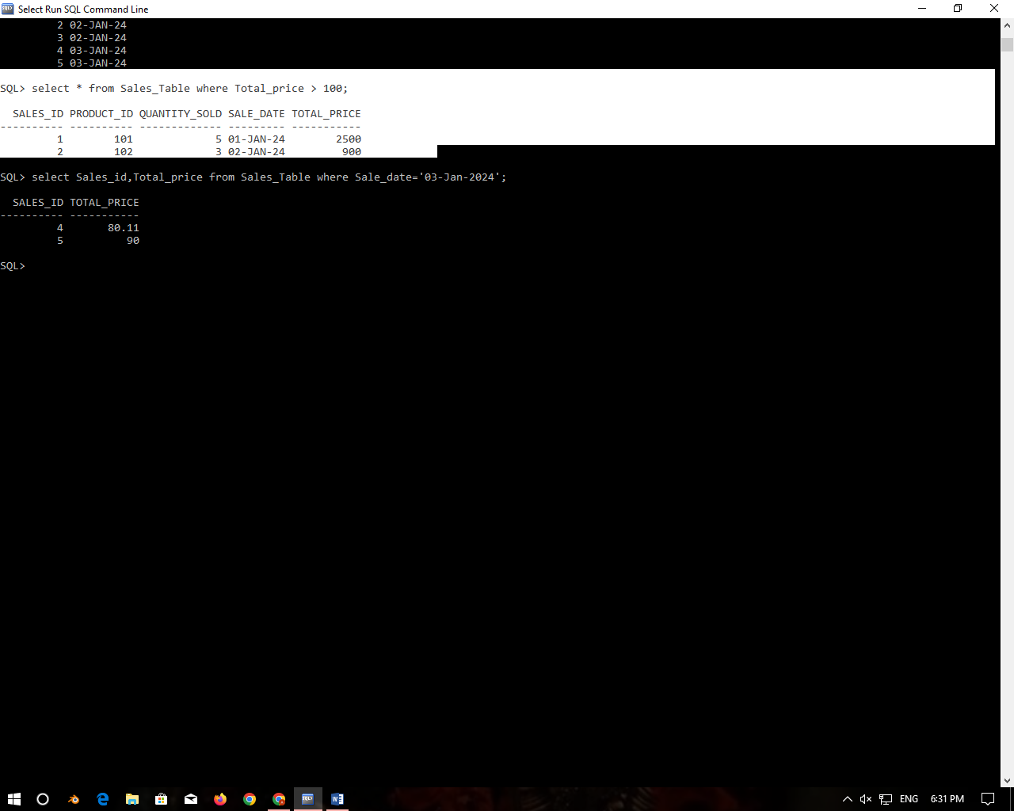

### 5. Retrieve the sale_id and total_price from the Sales table for sales made on January 3, 2024.

### 

### 6. Retrieve the sale_id, product_id, and total_price from the Sales table for sales with a quantity_sold greater than 4.

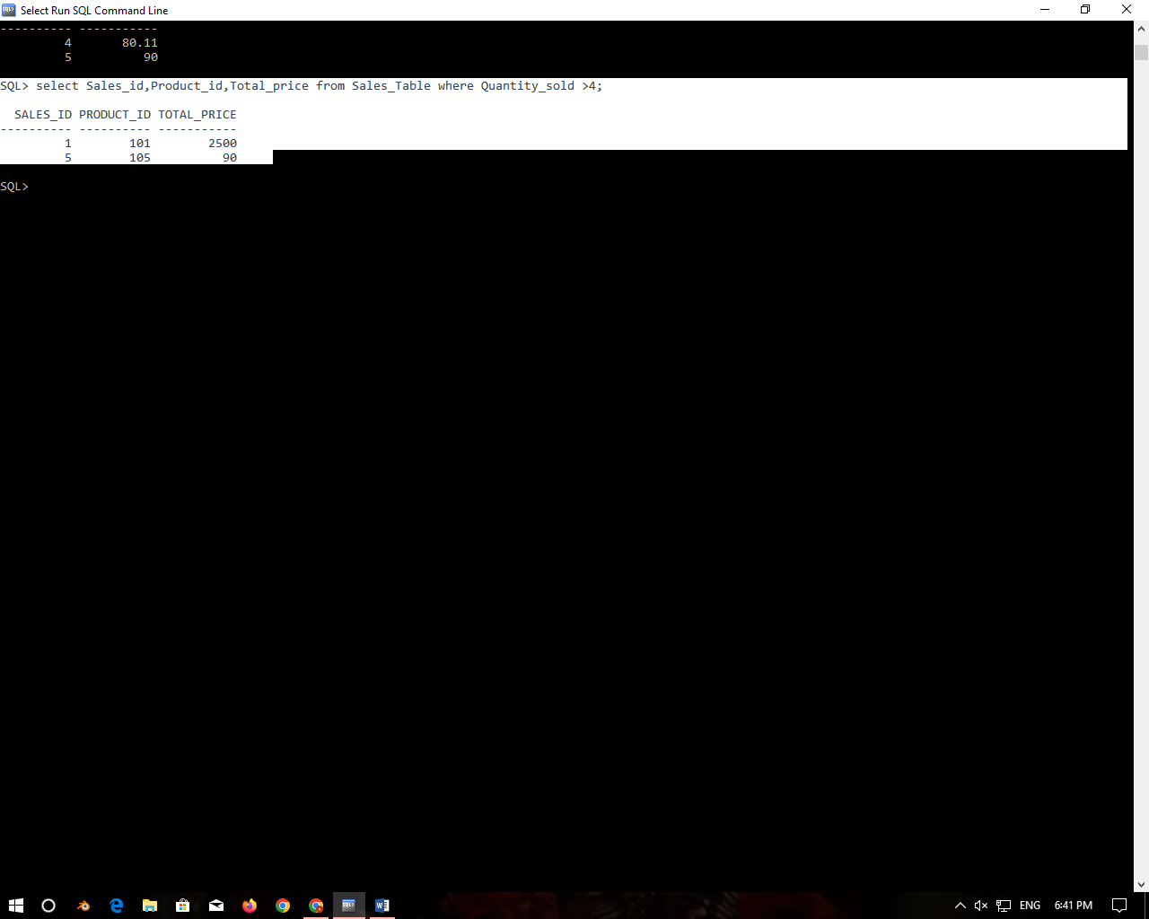

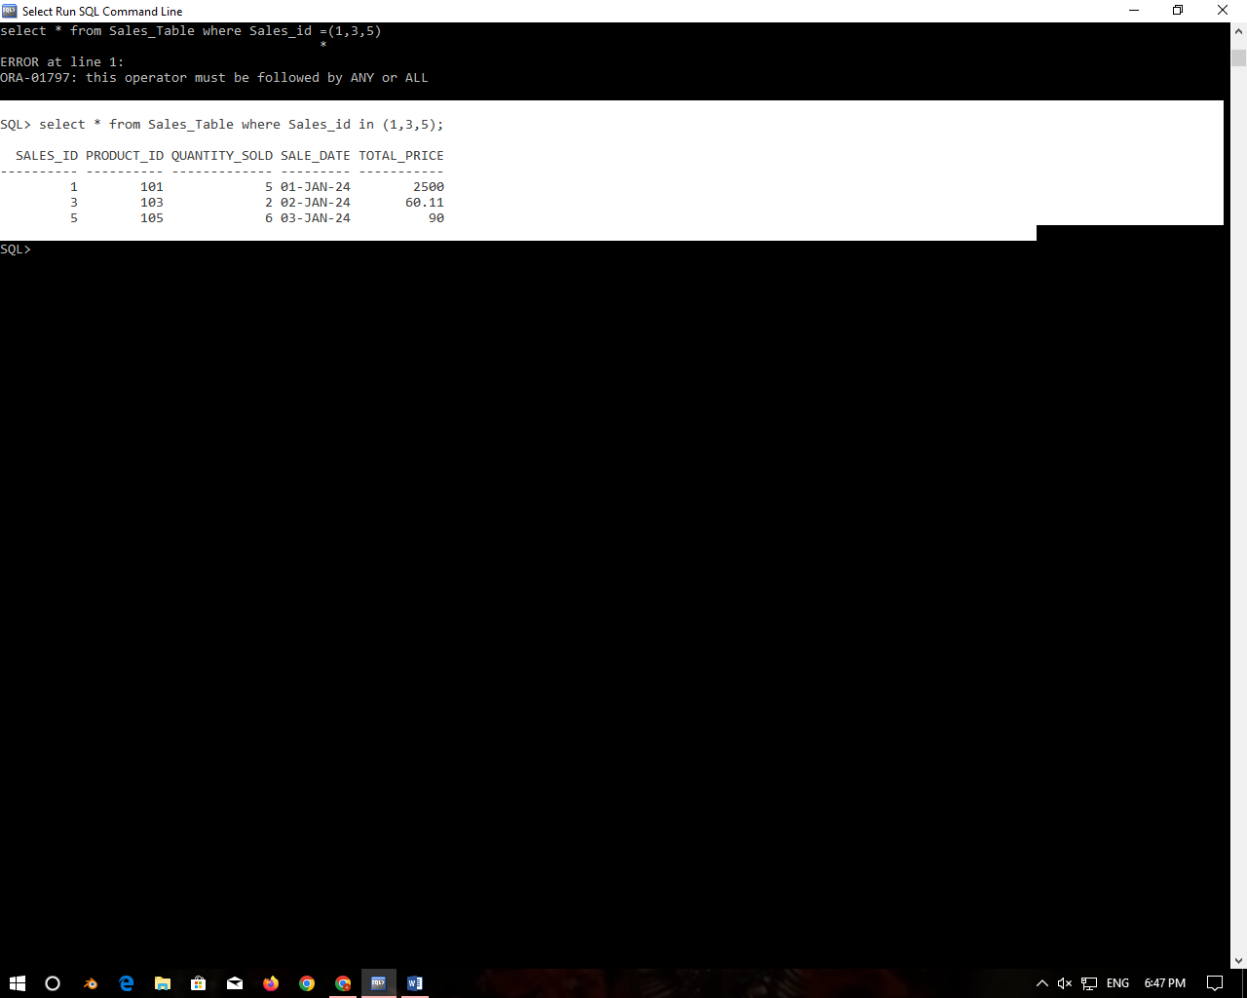7. **Retrieve all columns from the Sales table those sale_id are 1, 3 & 5.**

**8. Retrieve all columns from the Sales table those total_price between 90 and 1000.**

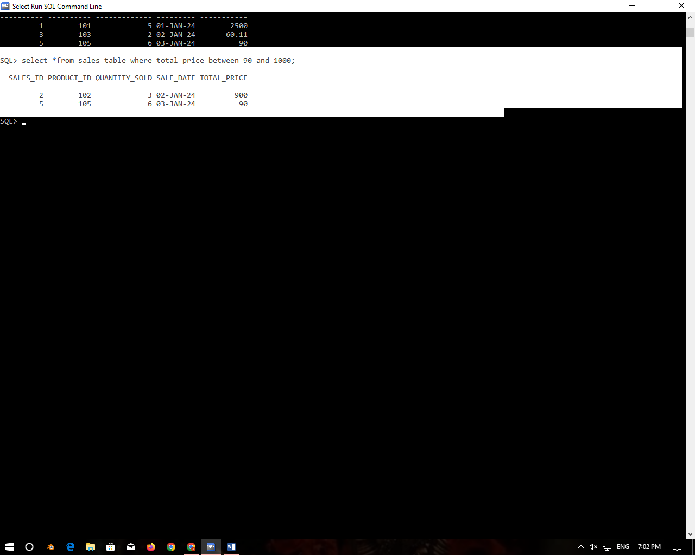

**9. Retrieve all columns from the Sales table those total_price not between 90 and 1000.**

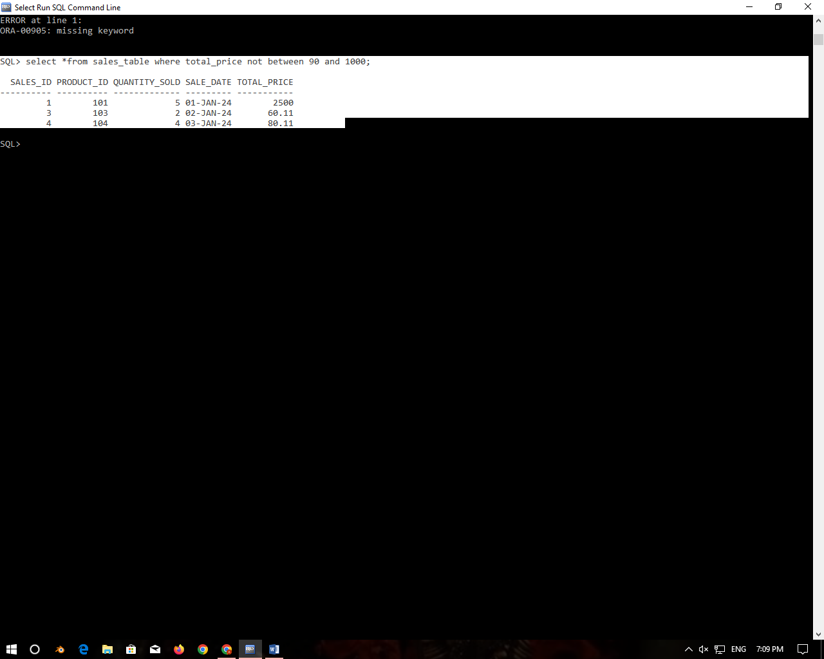

10. **Retrieve all columns from the Sales table those sale_id are not in 1, 3 & 5.**

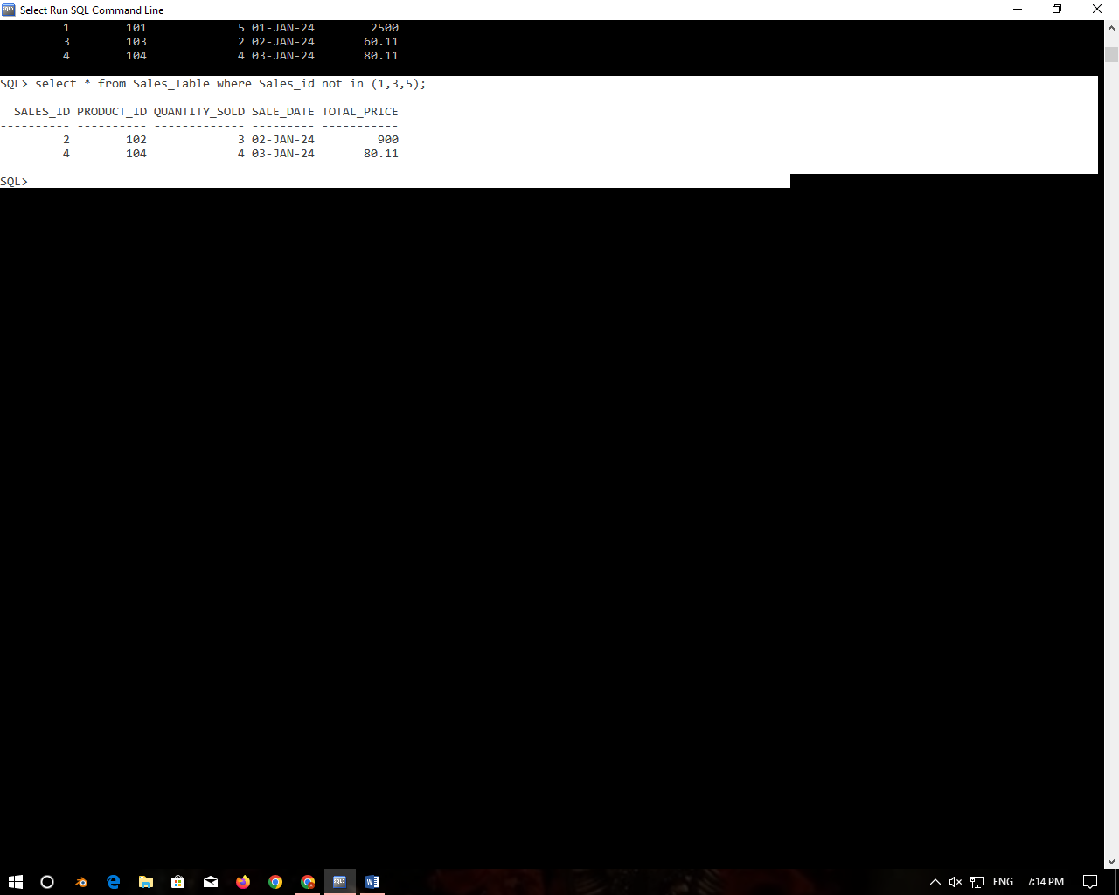

**11.  Update total_price as 500 in  the Sales table those sale_id are 1, 3 & 5.**

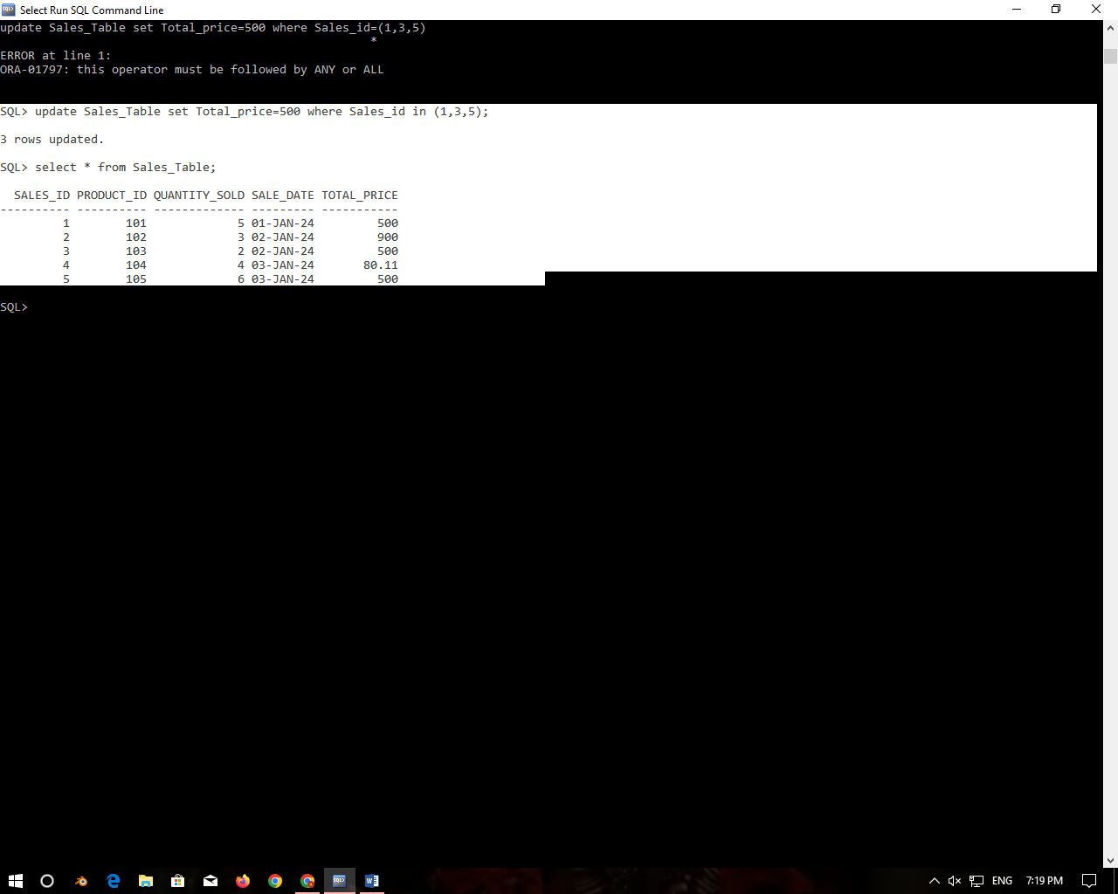

12. **delete from the Sales table those total_price not between 90 and 1000.**

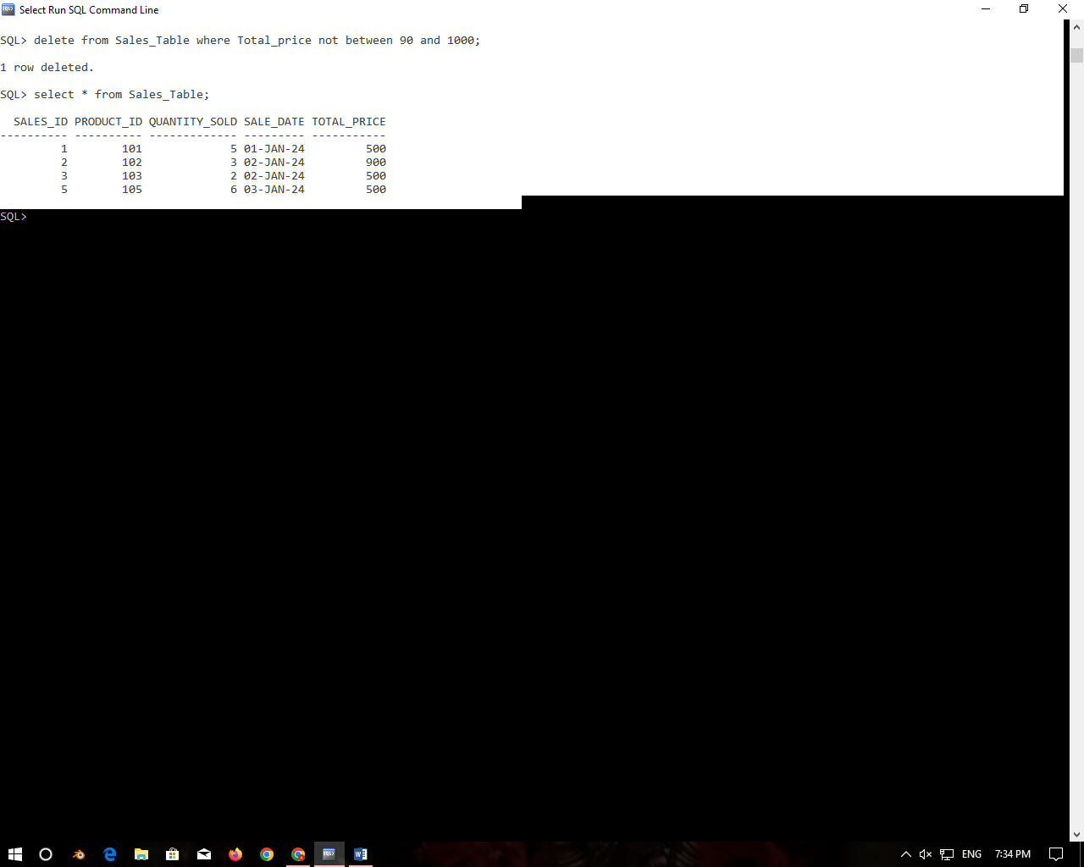

13.**Sort all the records using sale_id column in ascending order.**

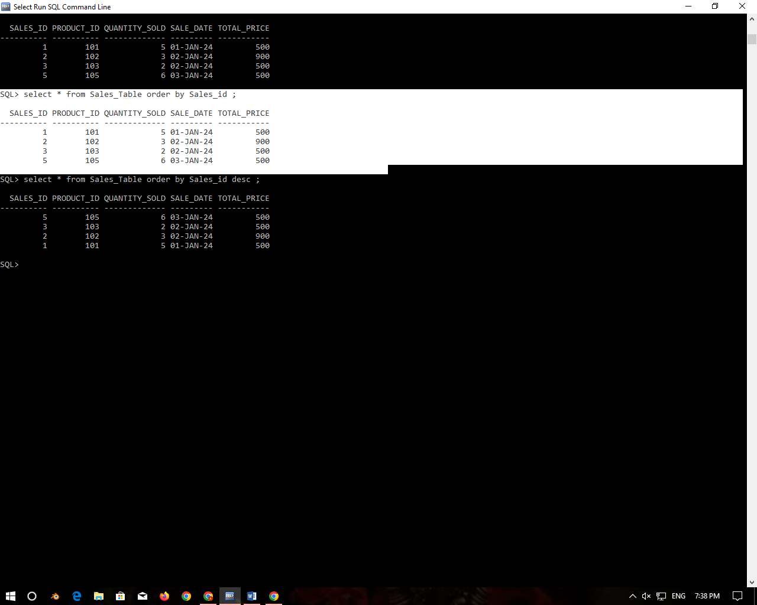

14. **Sort all the records using sale_id column in descending order.**

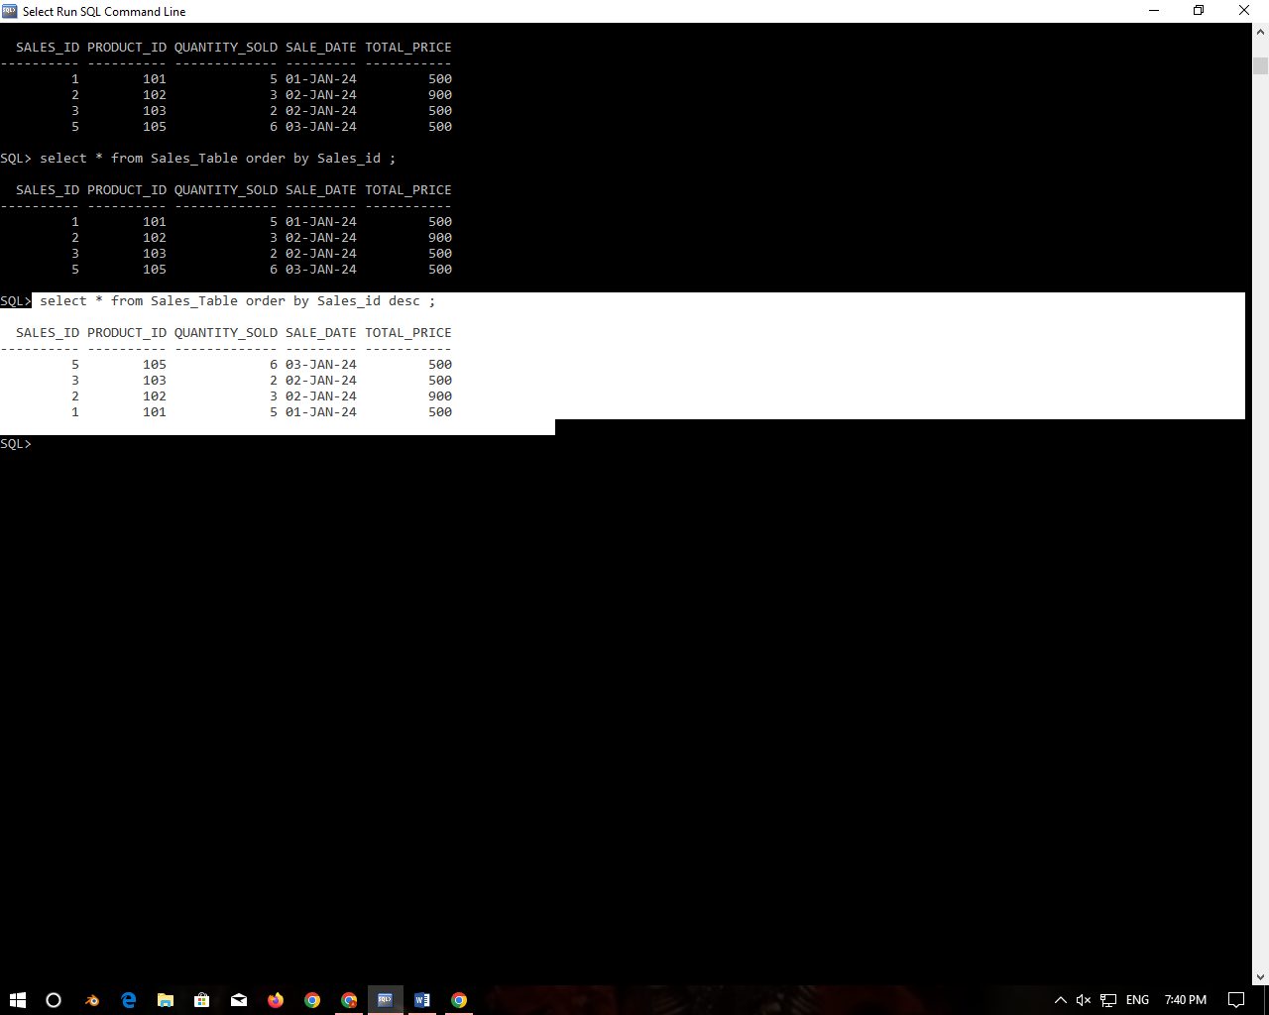

15. **Rename the sale_id column as sales_id;**

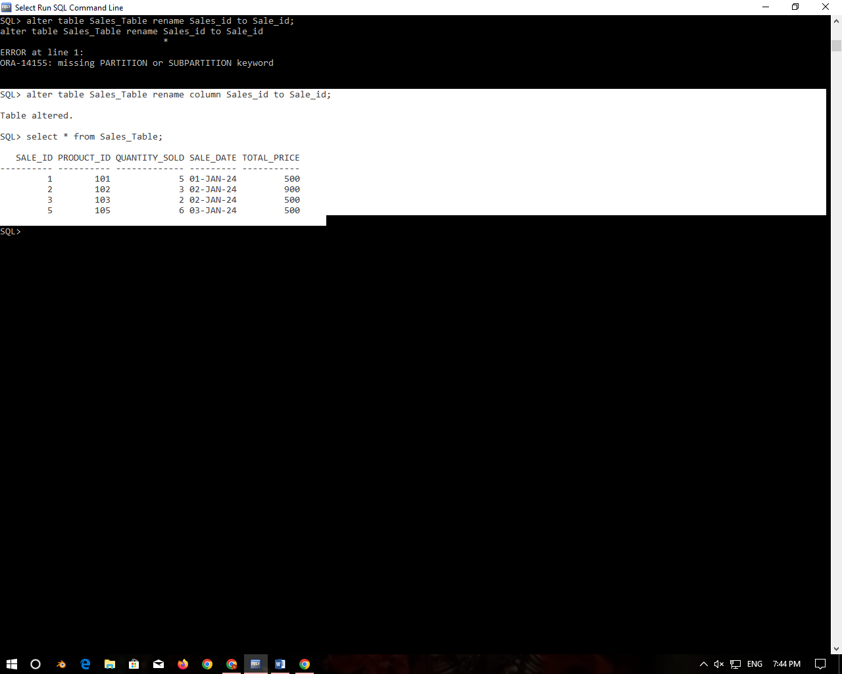

16. **Drop the column sales_id**

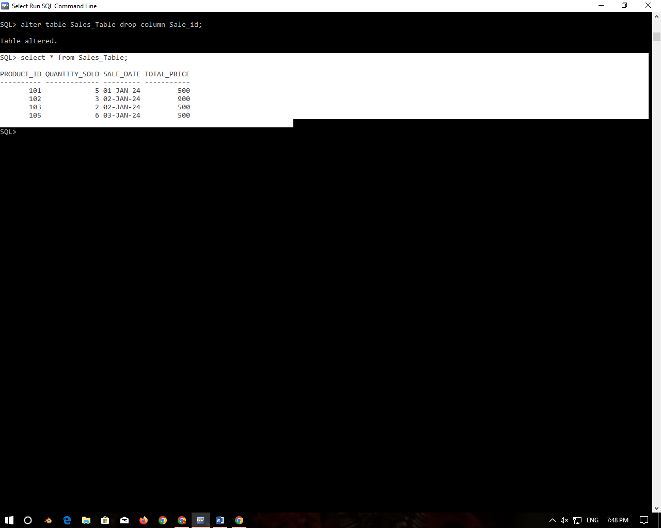

17. **Rename the table as tbl_sales.**

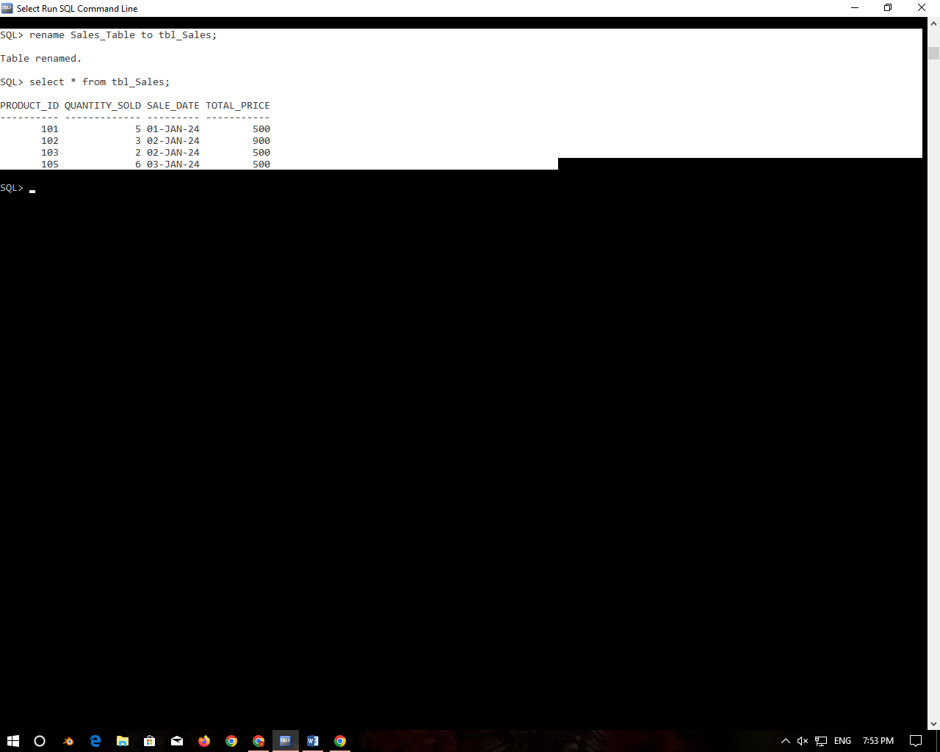

18.Drop the table.

